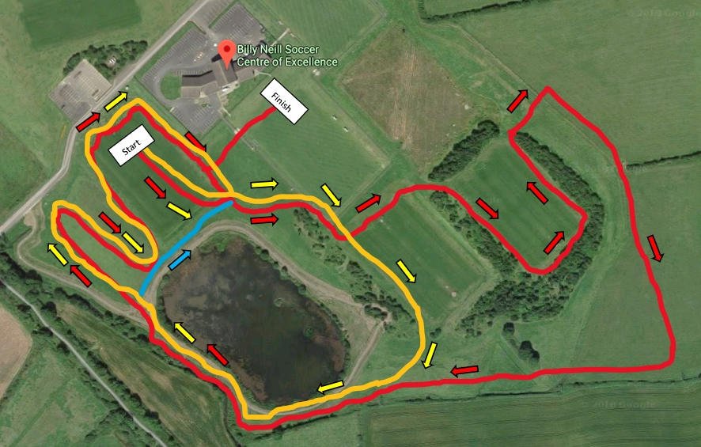
Red Lap = 2000m
Yellow Lap = 1500m
Short Yellow Lap (Blue) = 1000m

NI & Ulster Even Age Groups Championships & Bobby Rea Cross Country

U10 (Girls & Boys) – 1000m – 1 short Yellow Lap (blue line)
U12 (Girls & Boys) – 1500m – 1 Yellow Lap
U14 (Girls & Boys) – 2500m – 1 Short and 1 Full Yellow Lap
U20 & Senior & Masters Women & Men O60+ – 6000m – 3 Red Laps
U16 (Girls & Boys) – 3500m – 1 Yellow Lap + 1 Red Lap
U18 Girls – 4000m – 2 Red Laps
U18 Boys – 5000m – 2 yellow & 1 Red Lap
U20 & Senior & Masters Men – 8000m – 4 Red Laps
TIMETABLE:

GIRLS U10 – 1000m – 11am
BOYS U10 – 1000m – 11:10am
GIRLS U12 – 1500m – 11:20am
BOYS U12 – 1500m – 11:35am
GIRLS U14 – 2500m – 11:50am
BOYS U14 – 2500m – 12:10am
Senior/U20 Women and M60+ - 6000m – 12:40pm
GIRLS U16 – 3500m – 1:15pm
BOYS U16 – 3500m – 1:35pm
GIRLS U18 – 4000m – 1:55pm
BOYS U18 – 5000m – 2:20pm
Senior/U20m – 8000m – 2:50pm

